**[CO-2] [Blooms Taxonomy Level-4]**

**[CO-I] [Blooms Taxonomy Level-6]**

**Echelon Institute of Technology**

**ECHELON INSTITUTE OF TECHNOLOGY**

**Department of Computer Science & Engineering**

**Title of Assignment: Introduction To Operating System (BCA-DS-203)**

| **Course: BCA (DS), 3rd semester** |  | **Session: 2022-23** |
| --- | --- | --- |
| **Date of Issue: 05 Aug, 2023** |  | **Date of Submission: 14 Aug, 2023** |
| **Course Unit included: 1st** | **Max. Marks: 30** | **Assignment Number: 1st** |

**------------------------------------------------------------------------------------------------------------------------------------------------------**

**Learning Outcomes:**

**LO1: Learning fundamentals of operating systems.**

**LO2: To understand the basic concept of timesharing, multi-tasking, and multithreading.**

**LO3: To understand the CPU scheduling and practice numerical.**

**Question-1**

**Discuss the basic concept of timesharing and multithreading in operating systems. Discuss the view of an operating system as a resource manager.**

**Question-2**

**A scheduling mechanism should consider various scheduling criteria to realize the scheduling objectives. List out all the criteria.**

**Question-3**

**Consider the following process states and corresponding arrival time and burst time. Calculate the FCFS and SJF**

**[CO-1] [Blooms Taxonomy Level-4]**

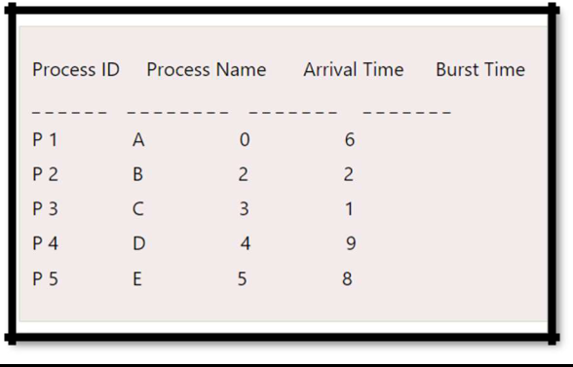

**Course Outcome Evaluation Matrix:**



| **CO/Ques** | **Qns-1** | **Qns-2** | **Qns-3** |
| --- | --- | --- | --- |
| **CO-1** | **√** | **-------** | **√** |
| **CO-2** | **-------** | **√** | **-------** |
| **CO-3** | **-------** | **√** | **-------** |
| **CO-4** | **-------** | **-------** | **-------** |
| **CO-5** | **-------** | **-------** | **-------** |

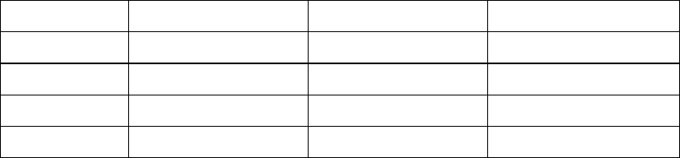

**Assignment prepared by: Mohammad Danish**



**Signature of Faculty**

**Department of Computer Science & Engineering**